Ernest Lowe and Black Okies

A new exhibit at the Fresno Art Museum opening Friday July 13th, sheds new light on the history of rural African-American communities in the San Joaquin Valley. It features the work of photographer and journalist Ernest Lowe. From 1960-1964 he documented life in the communities of Dos Palos and Pixley, with fine art, black and white photographs. A student of Dorothea Lange, Lowe's work captures the stories of black families who came to the valley during the Second World War, only to have their lives upended by the mechanization of agriculture a decade later. We spoke with photographer Joel Pickford, an accomplished photographer in his own right, who made the prints for this exhibit, and worked with the Lowe archive.
Check out the Valley Public Radio interview with one of the curators of the exhibit here:
http://kvpr.org/post/exhibit-captures-valleys-rural-african-american-communities-1960s-rare-photos
More information about "Black Okies" can be found here: http://ernestlowe.com/?p=678

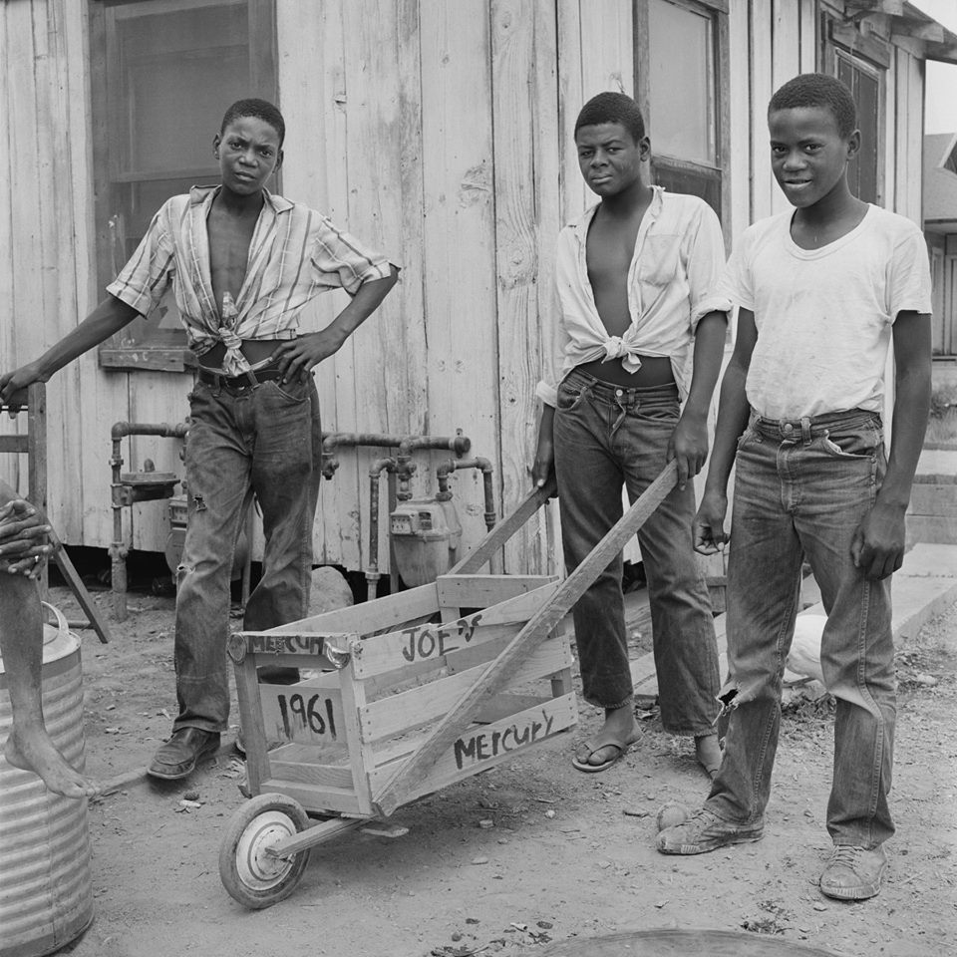

Black Okie History
http://ernestlowe.com/black-okie-history/
60s, Black Okies
The West of the West Center has produced Black Okies, a documentary on the history of Teviston directed by Joel Pickford. You can view this film by going to this site:
https://vimeo.com/user25968631/blackokies Enter the password (case sensitive): Bokies0415
Michael Essinger is a doctoral student at UC Merced who is studying the forgotten history of African-American communities up and down the Central Valley. You can view or download his papers at this site:
Black Okie History
Mark Arax, Director of the West of the West Center, wrote several articles on Teviston in 2002 when he was a reporter for the LA Times. These are available at:
http://articles.latimes.com/2002/aug/25/local/me-blackokies1
http://articles.latimes.com/2002/aug/26/local/me-blackokies2
http://articles.latimes.com/2002/aug/26/local/me-okieside26
http://articles.latimes.com/2002/aug/27/local/me-blackokies3
https://www.fresnobee.com/opinion/article214651220.html
Mark speaks of the migration to rural California and some of the people he found in Teviston in this video:
https://www.youtube.com/watch?v=7LPBEb5PXBk&feature=youtu.be
Acres of Aspiration by Hannibal Johnson documents the all Black towns established in Oklahoma from the 1890s to the 1920s. They attracted independent, hard-working families from the deep South. This helps explain the strength of the younger generation that moved to California in the 50s to found Teviston and other primarily Black communities in California. One can order from Alibris.com.

